N-Queen Problem (9-Queen Problem)

Aim
To place 9 queens on a 9×9 chessboard so that no two queens attack each other using Artificial Intelligence techniques.

Objectives
- To understand constraint satisfaction problems (CSP).
- To implement backtracking.
- To find a valid arrangement of 9 queens.
- To improve problem-solving skills in AI.

Algorithm
- Start.
- Place a queen in the first column.
- Check if the position is safe.
- If safe, place the queen and move to the next column.
- If no safe position exists, backtrack to the previous column.
- Repeat until all 9 queens are placed.
- Display the board.
- Stop.
- 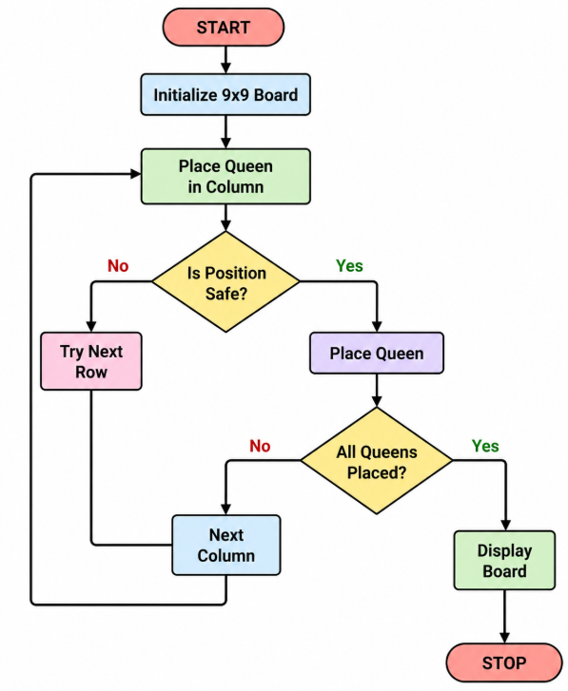
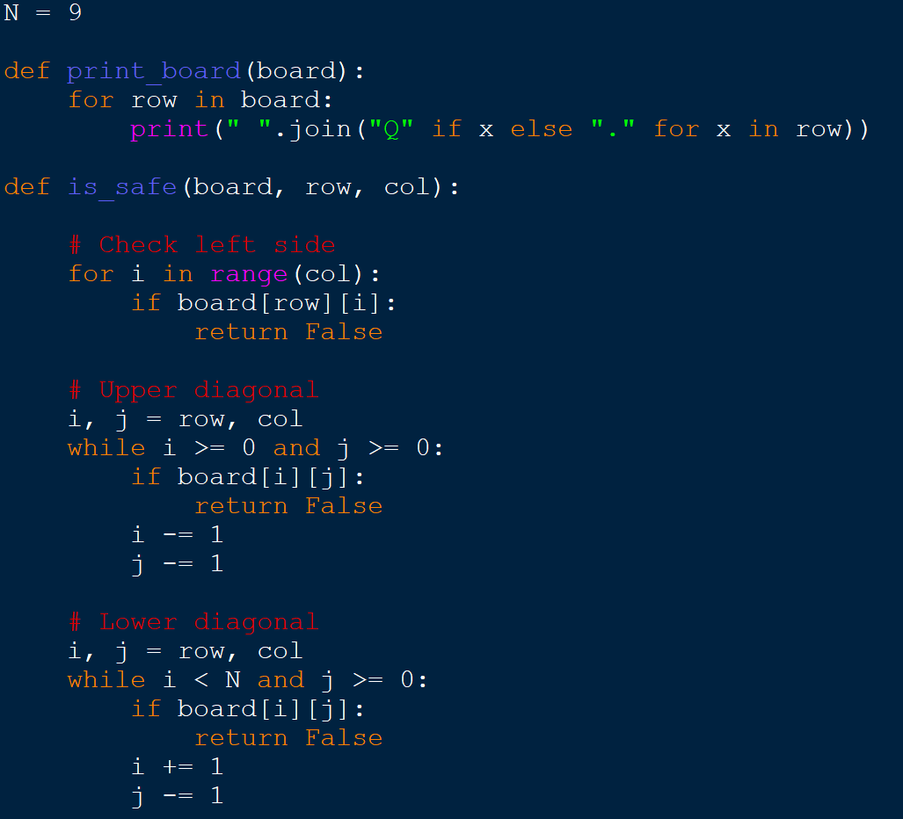
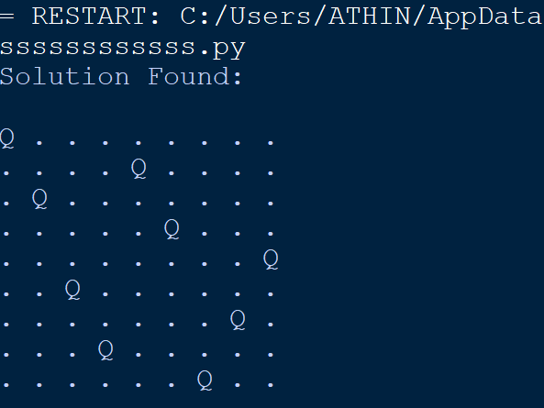
Result
The 9-Queen Problem was successfully solved using the Backtracking Algorithm. A valid arrangement of 9 queens on a 9×9 chessboard was obtained without any conflicts.

